- Creating and Renaming Files/Directories
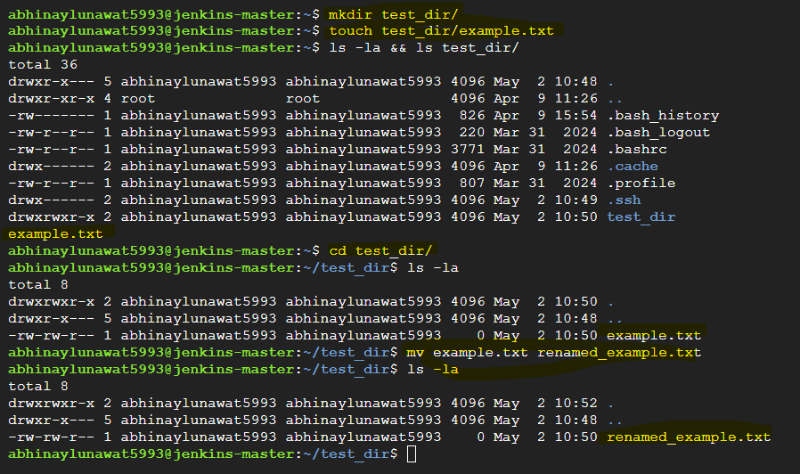

- Viewing File Contents
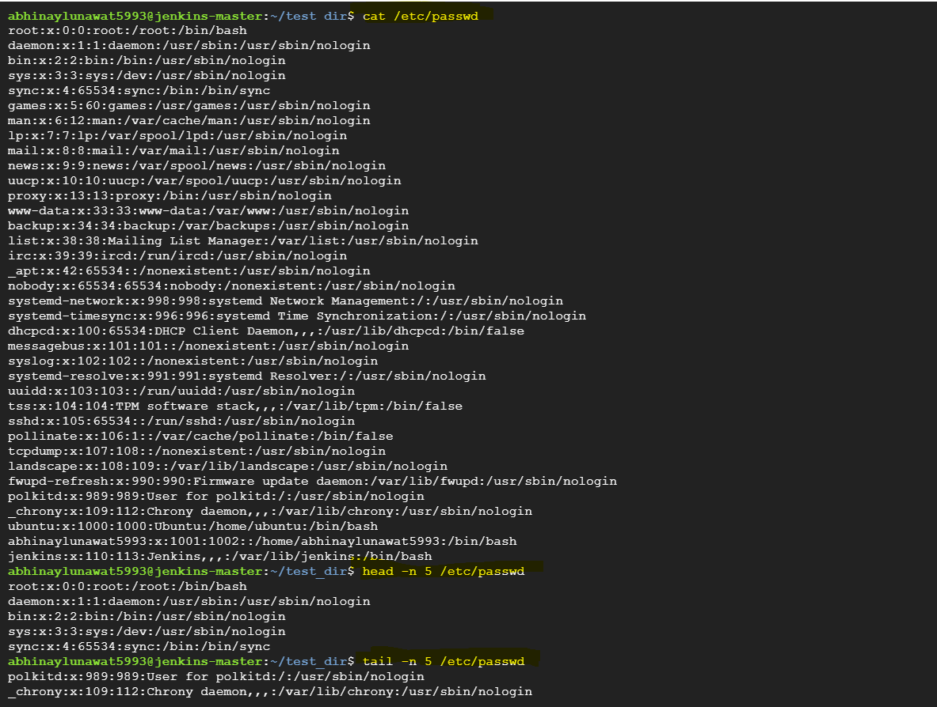
- Searching for Patterns In the mentioned command along with grep the flag -n is mentioned to display the line number for the filtered result.
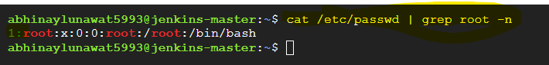

- Zipping and Unzipping
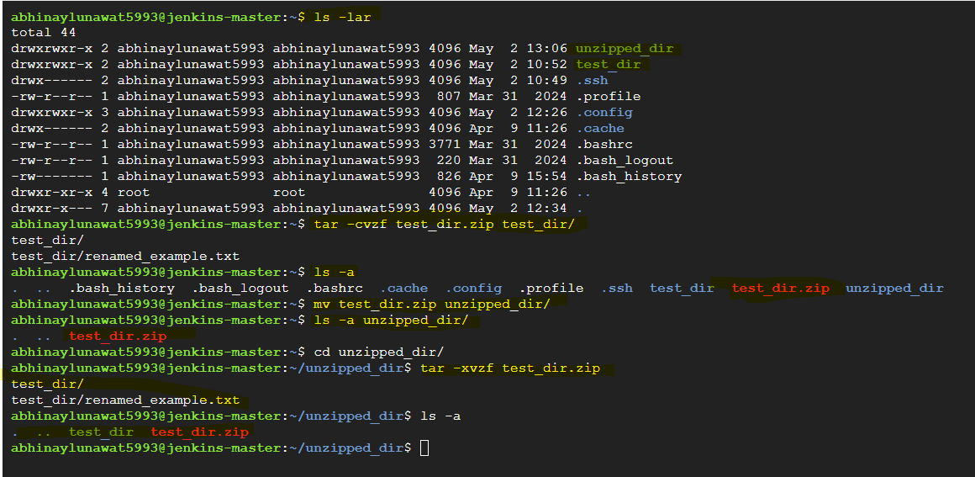

- Downloading Files
Downloading the .txt file from - https://gist.githubusercontent.com/Talha-Altair/b8a27d2b45add1dd7658fd34fa1968db/raw/bc45208c96df65e8e659c04e7d1f1bb54ec5b7e2/linux_commands.txt

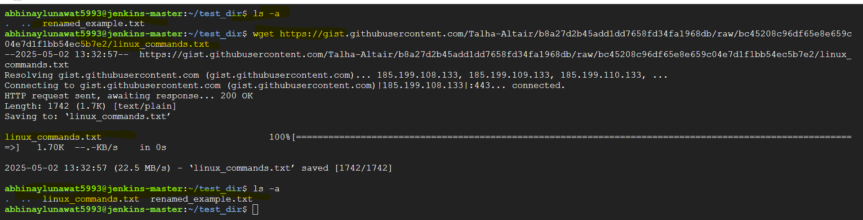
- Changing Permissions

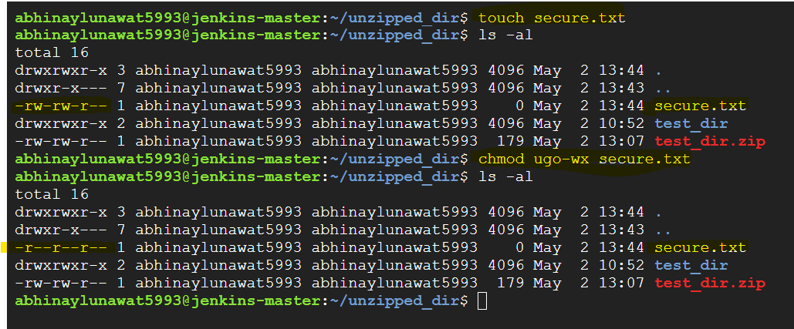

- Working with Environment Variables

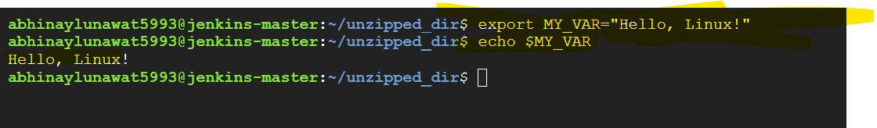

Thanks,
Abhinay Lunawat
Abhinaylunawat5993@gmail.com

